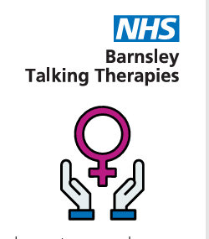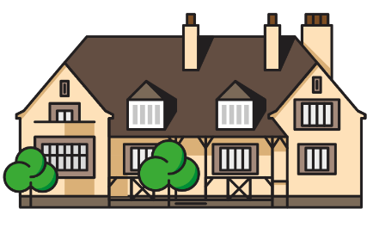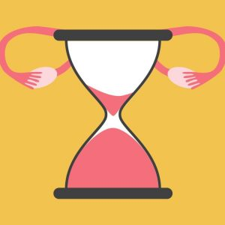
Perimenopause and Menopause Course 2026 & 2027

A two-part workshop to be held at the Recovery College ran by Talking Therapies.
This workshop is aimed at getting people to talk about their experiences, their symptoms and at the same time improve knowledge and understanding of the impact this journey can have on our lives.
We explore the following:-
- Some guidance and advice on HRT myths and truths
- Stages of the menopause
- How to pinpoint bothersome symptoms in relation to frequency and distress and what to do about them
- Pelvic floor health
- Menopause at work
- What to expect at the doctors and where further medical support can be found
- Introduction of CBT Cognitive Behavioural Therapeutic interventions to help support you with managing symptoms, challenging thoughts and behaviours
- Opportunity to share hints and tips, Apps and books.
- Information for partners/carers/families of living with the menopause
We know that everyone is different but all of us together can make a difference to our lives and the challenges of living with the menopause.
Ran by NHS Barnsley Talking Therapies 01226 644900 at Barnsley Recovery & Wellbeing College www.barnsleyrecoverycollege.nhs.uk 01226 730433
Wednesday at Barnsley Recovery College | 14th & 21st October 2026 | 10am-12
Wednesday at Barnsley Recovery College | 3rd & 10th February 2027 | 10am-12

Disclaimer: The workshop has been designed by Senior Psychological Wellbeing Practitioners from Barnsley Talking Therapies Team it is not a replacement for medical advice/intervention. If you have any medical queries about the menopause or medication please see your GP/nurse prescriber/menopause specialist for further guidance.

